**Concept of Git merging**

The concept of git merging is basically to merge multiple sequences of commits, stored in multiple branches in a unified history or to be simple you can say in a single branch.

What happens is when we try to merge two branches, git takes two commit pointers and starts searching for a common base commit in those two specified bit branches. When git finds the common base commit it simply creates a “merge commit” automatically and merges each queued merge commit sequence.

3 Ways Merge:-

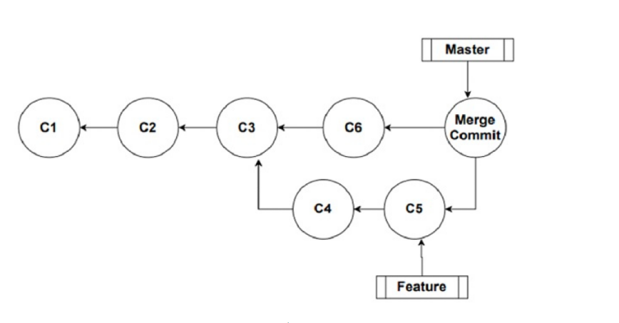

Above figure show the clear picture of 3 way merge.

a)file1.txt is created in main branch with commited.

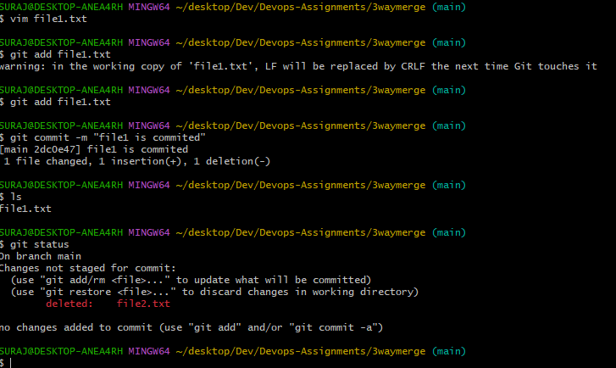

b)File2.txt is created in main branch with commited.

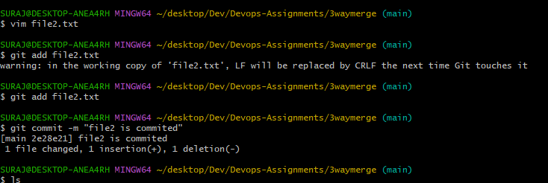

c)File4.txt is created in test branch with commited.

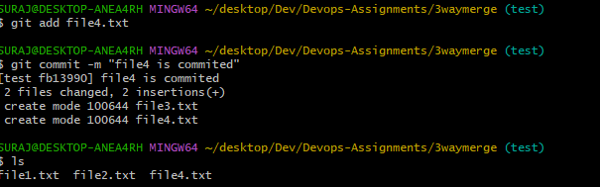 d)File5.txt is created in test branch with commited.

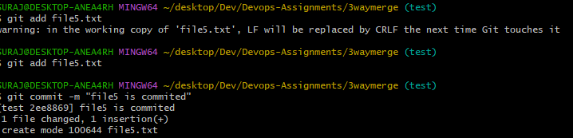

e)Agin file3.txt is created in main branch with commited.

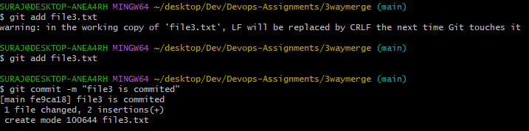

f)Again in main branch file6.txt is created with commited .

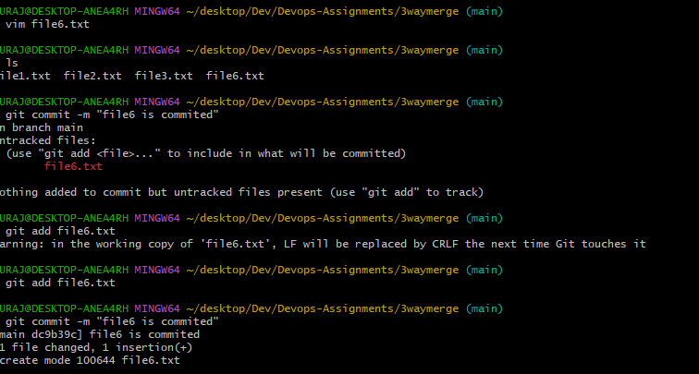

i)git log –graph –pretty=oneline using this command is display the result how many files are commited in main branch , test branch and showing head pointer point to file6 in main branch.

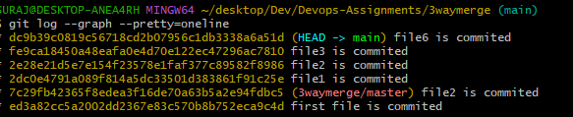

j)git log –graph –pretty=oneline using this command is display the result how many files are commited in main branch , test branch and showing head pointer point to file5 in main test branch.

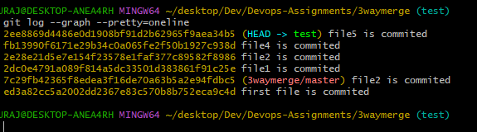

k)After that git merge test command executed in main branch see conflict error.

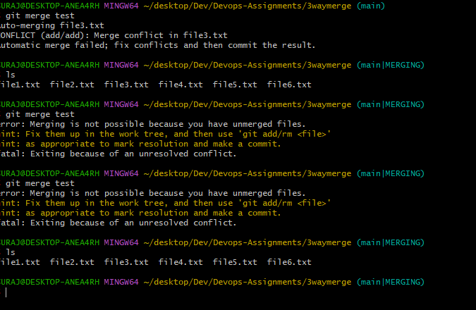

l)After the resolution conflict executed the git merge test inside the main branch see result all commited files merge into main branch from test branch.

